# 

# Economical demand-side management with distributed energy resources

|  |  |
| --- | --- |
|  |  |
|  |  |
|  |  |
|  |  |
|  |  |
|  |  |
|  |  |

**CHAPTER 1**

**1.1 INTRODUCTION:**

Demand side management is an important aspect of managing the energy system. The process involves matching the amount of energy being produced with the amount of energy being consumed. A difficult issue because there is not enough storage available and financially feasible. Time dealing with the current situation. It is now necessary to address the peak demand because of the expensive cost of the immediate market and traffic in the delivery system may need to reassess their current approach and consider implementing new strategies to address these emerging challenges. Indicates there is a growing global recognition and admiration for load flexibility.  
The term used to describe this concept is called Demand Response (DR), which aims to raise the level of  
the system to make it more efficient and increase flexibility. Demand refers to the quantity of a good or service that consumers are willing and able to purchase at a given price and within a specific time period. System is no longer considered acceptable. The system is in danger and the market price is at risk in the near future.  
The competition for supplying peak load is intense. Demand response refers to the practice of adjusting electricity consumption in response to changes in power supply or pricing. Demand response (DR) refers to the procedure of altering electricity usage (Change their behaviour). The introduction of smart grid technology has made it possible to put into action. The text mentions the use of advanced DR techniques. DR aids in the process of integration. Renewable distributed energy resources can be changed by making modifications to the system. Enhance the energy efficiency and dependability by enabling the incorporation of profiles. Demand Response is advantageous not only for the distribution utilities, but also the consumers. One-way individuals can reduce their electricity expenses is by engaging in demand response.

According to the load profile, consumers can be classified as Residential, Commercial and Industrial. The quantum of the load is quite different among these sectors. Moreover, according to the type of control, DR can be classified into two categories, centralized control and distributed control. Communication infrastructure and decision centre are the major difference between these two [12]. In centralized control, DR aggregator takes the decision and communicates it to the consumers individually. There is no communication link between the consumers. In decentralized control, only DR aggregator communicates the price signal to the consumers and the decision is taken by the consumer. There is a communication infrastructure between consumers. Decentralized control can have multiple objectives such as voltage balance, frequency regulation and dynamic stability etc. to improve the health of the grid.

However, power system has made significant technical advancement, still distribution system is struggling to address the growing demand. The energy demand is increasing in all the sectors as residential, industrial and commercial. The residential sector has significant energy conservation potential as averaged worldwide; the residential sector consumes approximately 30% of the total energy consumption [13]. Therefore, it is required to focus on techniques to decrease energy consumption in residential sector.

The basic idea behind designing a good Demand Response strategy is to give certain incentives to the electricity consumers to alter their consumption pattern which is beneficial not only to the consumers from the financial perspective but also to the electricity provider and overall reliability of the power system [14]. Various pricing mechanism for DR schemes such as Time of Use (TOI), Real Time Pricing (RTP) and Critical Peak Pricing (CPP) have been developed which addresses the above objectives [8].

**1.2 Key Challenges:**

One of the main difficulties in carrying out successful DSM (Demand Side Management) programs is finding appropriate customers who are able to engage in demand response initiatives. These individuals, commonly known as "DSM candidates," are essential in meeting high demand periods and decreasing energy usage during expensive hours.

**1.3 Literature Survey:**

|  |  |
| --- | --- |
| Name | Summary |
| Intelligent techniques for mppt control in photovoltaic systems: A comprehensive review | * Photovoltaic power generation is a method that harnesses solar energy to create electric power and is considered a form of renewable energy. * The usage of these systems is increasing due to scarce resources and the pressing energy crisis. * This paper provides a literature review on the latest advancements in AI algorithms for maximum power tracking control. * The purpose of maximum power tracking algorithms is to optimize the power output of a photovoltaic system by adjusting the load resistance to match the input resistance of the source. * This article evaluates the performances of different algorithms in the field, focusing specifically on AI algorithms that have shown superior effectiveness. The article also cites the latest advancements made in each algorithm. * This manuscript is intended to be a useful source of information for upcoming research on controlling maximum power tracking control. |
| CEER Advice on ensuring market and regulatory arrangements help deliver Demand-Side flexibility | * Demand-side flexibility refers to the ability of consumers to adjust their energy usage to align with changes in demand or supply conditions. * The ability to provide various advantages, such as decreased expenses for systems and consumption. * Improved power supply reliability and increased capacity for accommodating intermittent renewable energy sources. renewable energy sources (RES). * This text discusses the context, explanations, potential advantages, and obstacles connected with the rise of DSM. |
| A survey on demand response programs in smart grids: Pricing methods and optimization algorithms | * Demand Response (DR) is seen as the most economical and dependable method for managing fluctuations in demand when the system is experiencing strain. * Demand Response (DR) is a methodology employed to encourage modifications in customers' energy usage behaviours as a result of incentives related to electricity costs. * This article, offer a thorough examination of different demand response initiatives and systems, focusing on the incentives provided to consumers to encourage their participation in these programs. * They categorize the suggested DR strategies based on their method of control, the reasons provided for reducing power usage, and the variable used to make the DR decision |
| Demand side management: Demand response, intelligent energy systems, and smart loads | * Demand Side Management (DSM) refers to a collection of strategies aimed at enhancing the energy system from the consumer's perspective. * The scope of actions varies, including enhancing energy efficiency through the use of improved materials, implementing intelligent energy pricing plans that offer incentives for specific consumption patterns, and implementing advanced real-time control of dispersed energy sources. * This article provides a summary and classification for DSM, examines different forms of DSM, and presents information about the most recent demonstration projects in the field. |
| Load pattern-based classification of electricity customers | * Having precise knowledge about how customers consume electricity is a valuable resource for electricity providers in competitive electricity markets. * This paper targets two strategies for categorizing customers, namely, a revised follow-the-leader algorithm and the self-organizing maps. * They evaluate the outcomes acquired from the two methods using two appropriately established measures of effectiveness, and examine the potential uses of the examined methods. |
| Data-driven targeting of customers for demand response | * They suggest a scalable approach for implementing a Demand Response (DR) program by using new data obtained from smart meters at the individual level. * The method involves presenting the problem as a stochastic knapsack problem, which includes forecasting how customers will respond. * A new and effective algorithm is created that can be used on large-scale problems with millions of customers. * The method was tested through actual experimentation with smart meter data from residential households. |
| Are domestic load profiles stable over time? An attempt to identify target households for demand side management campaigns | * They demonstrate that modifying the implementation of the K-Means algorithm improves the clustering outcomes of the entire time series while maintaining practical feasibility. * Characteristic load profiles enable us to categorize customers, target households with comparable consumption behaviours, and promptly identify the cluster that a particular load curve belongs to. |
| Reconfiguration of balanced and unbalanced distribution systems for cost minimization | * Therefore, the objective of this paper is to create a straightforward approach for rearranging distribution systems in order to minimize the cost of purchasing real power. * The suggested approach is appropriate for distribution systems that have both balanced and unbalanced conditions. The algorithm is evaluated on both balanced and unbalanced distribution systems, and the results are compared with those obtained using a more rigorous improved harmony search (IHS) technique. |
| A statistical demand-price model with its application in optimal real-time price | * This study examines the price sensitivity of electricity demand within a smart grid system. * In light of this observation, a new parametric utility model is introduced that effectively represents the price elasticity behaviours of combined loads as a collection of demand-price functions with multiple dimensions. * The advanced demand elasticity model is also used to calculate the best price indication for Real-Time Pricing (RTP) driven Demand Response (DR) initiatives. * The proposed methods are further demonstrated by presenting numerical examples from a 6-bus test system. |
| Factoring the elasticity of demand in electricity prices | * This article examines how the market structure can impact the responsiveness of electricity demand. The text goes on to explain how consumer behavior can be represented using a matrix that includes self-elasticities and cross-elasticities. * The text discusses the incorporation of these elasticities in the process of planning the generation and determining the electricity price in a pool-based electricity market. These ideas are demonstrated using a system composed of 26 generators. |

**1.4 Data Set and Visualisation:**

The total of 300 customers of yearly data set with their consumption with a 30 minutes time interval and also the PV generation with 30 minutes time interval.

The PV generation capacity of all customers

Mean at 1.68 kW, most (75%) are between 1 and 2 kW and some (2%) are around 6, 8 or 10 kW.

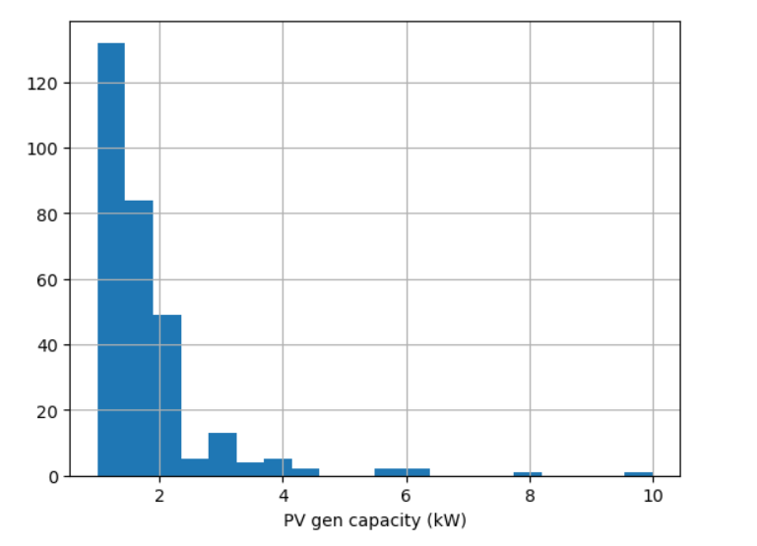

Number of customers.

Fig. 1. Histogram of PV generation capacity of all customers.

The general consumption (GC) and Gross generation (GG) of customer no. 100 of three day 1,2 and 3 July.

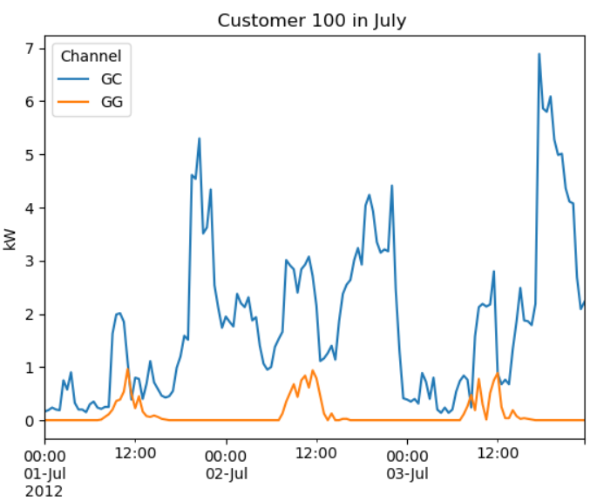

Fig. 2. General load curve of a particular customer 100 for three days.

The PV production of customer no.1,4 and 100 of three day 1,2 and 3 July

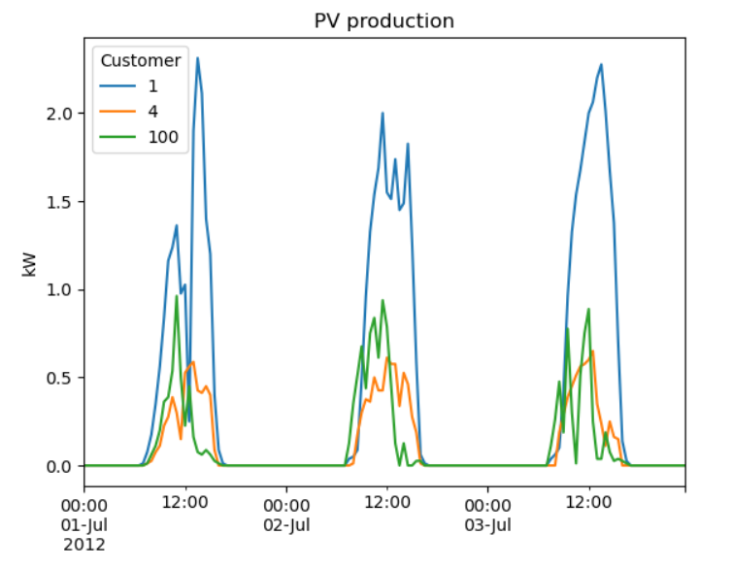

Fig. 2. General PV production curve of some particular customers for three days.

The PV production of customer 1 over a year

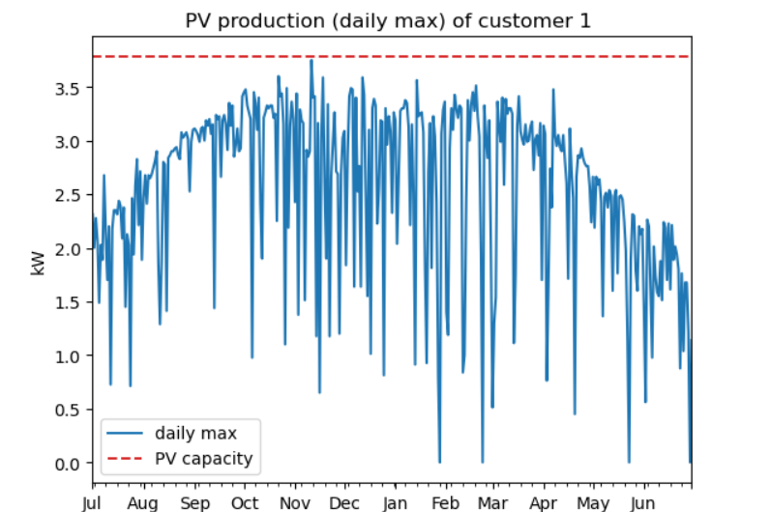

Fig. 3. General PV production (daily max) of customer 1 over a time period of one year.

**1.4 Approach to the Problem**

**CHAPTER 2**

**MATHEMATICAL MODELING/EXPERIMENTAL METHODS AND MATERIALS**

This research aims to identify the exact residential customers who should be targeted for participation in a demand response (DR) program, before its actual commencement. The detection process uses three crucial technical elements:

1. Characterization on the basis of load magnitude.
2. Characterization on the basis of peak timing.
3. Characterization on the basis of load flexibility.

When assessing controllability, the presence of HVAC systems (essential) and nonessential appliances is considered for indicating the flexibility of load. The flowchart describing how qualified residential applicants are selected for the demand response (DR) program appears in Fig 4.

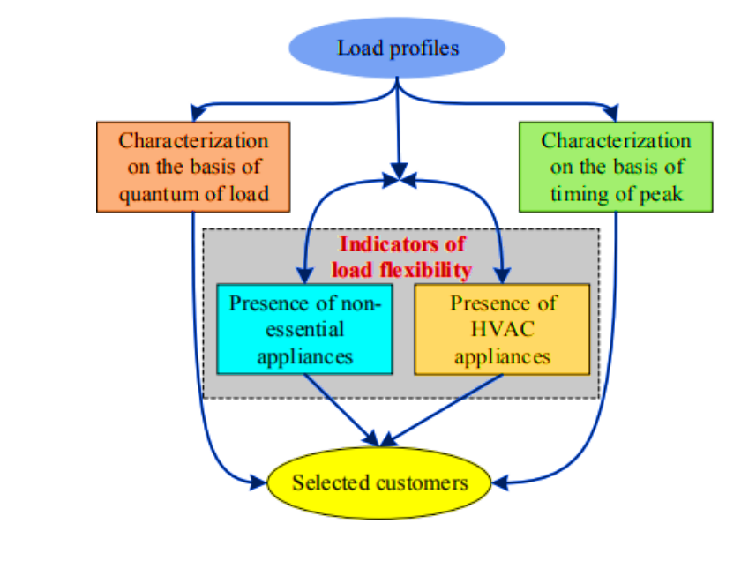

Fig. 4. Procedure to pinpoint the target consumer.

**2.1** **Characterization on the basis of load magnitude.**

Load profiling defines the residential, business, and industrial constituents of a customer base. These sectors require disparate treatment in a strong demand response (DR) system because of their diverse load patterns and magnitudes. Residential participation in DR programs has historically been limited by their being subsumed within more significant consumption levels than their own. However, energy intensity among residential consumers remains an important determinant for attaining DR effectiveness. It highlights why it is important to know how big the residential load is.

**2.2** **Characterization on the basis of peak timing.**

In this method, the clusters chosen for specific DR occurrences are based on their peak demand timings which have been proven to attract the highest consumer interest rates when compared to other times in a year with regard to electricity usage by residents at home and offices. Load profiles are effectively identified through peak occurrence intervals using k-means.

**2.2.1 K-means**

K-means clustering is a type of machine learning algorithm that is used to divide a dataset into groups of similar items without prior labelling or guidance. The goal is to categorize similar data points and uncover hidden patterns within the data. It is commonly utilized in several industries, including data mining, pattern identification, and isolating images.

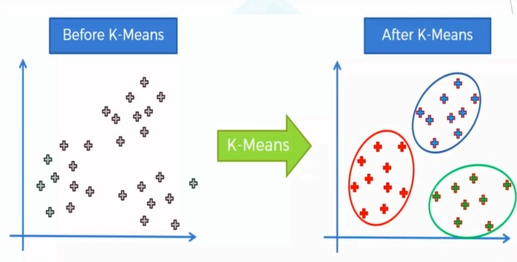

Fig. 5. Visualisation of K-means on data.

The way the algorithm operates is described as follows:

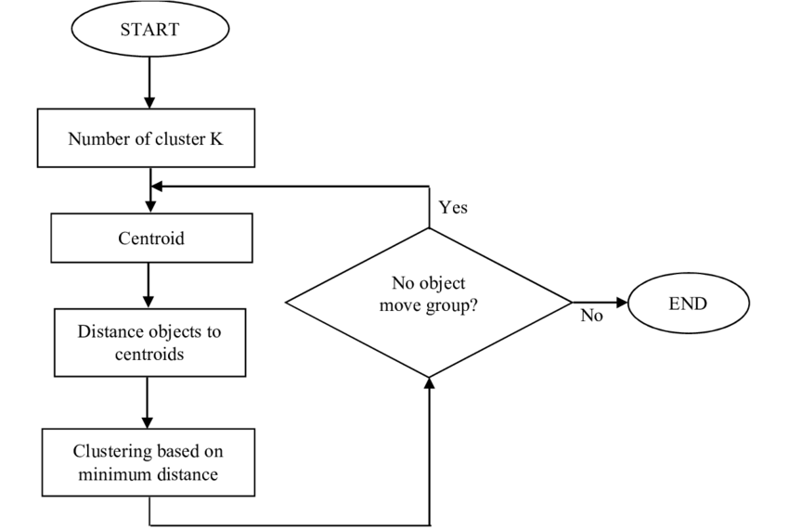

Fig. 6. Flow chart of k-means clustering algorithm.

Initialization: Select the number of clusters, k initialize randomly. "Solve for k. Grouping of data points into k distinct clusters using centroid-based clustering algorithm. These centroids indicate the focal points of the groupings.

Task: Compute the distance between each data point in the dataset and every cluster centroid. The usual method for calculating this is to use the Euclidean distance. Place the data point into the cluster that has the closest centroid.

Rewrite: Centroids Update: Once all data points have been assigned to clusters, recalculate the centroids of each cluster by determining the average of the data points within each cluster.

The process of assigning and updating centroids should be repeated until convergence is achieved. Convergence is reached either when there is minimal change in the centroids or when a predetermined number of iterations has been completed.

Conclusion: After achieving convergence, the algorithm has determined the cluster centres and assigned every data point to a particular cluster. At this point, the clusters are a reflection of sets of data points that share similarities with each other and differ from the points in other clusters.

K-means is a repetitive process that aims to reduce the variability within clusters by minimizing the inertia or total squared distance between each point and its assigned centre. initial number of clusters. It should be acknowledged that the performance of the k-means algorithm can be affected by the initial selection of centroids and the decision of how many clusters to use.

The optimised way to select number of clusters is by using the elbow method.

**2.2.1.(a)Elbow method**

The elbow method is a practical method used to find the best number of clusters ("k").In a k-means clustering algorithm. The process includes creating a graph that shows the sum of squares within each cluster as a function of the number of clusters. The objective is to find a point in the graph where there is a significant slowdown in the rate of decrease for the sum of squares.  
This is the process of how the elbow method functions:  
1. Execute the K-means algorithm using varying values of, "k".  
2. Rewrite: The k values vary from 1 to a predetermined maximum number of clusters. For every given value of n. Calculate the within-cluster sum of squares (WCSS) by summing the squared distances between every data point and the centroid it is assigned to within the cluster.  
3. Graph the Within Cluster Sum of Squares (WCSS) in relation to k. Generate a graph that shows the plot of WCSS values along with their corresponding values. This will typically result in a decreasing curve where the WCSS decreases as 𝑘 increases.

4. Determine the elbow point by analysing the graph and locating the moment at which the decline rate of WCSS noticeably decelerates. This specific point is referred to as the "elbow" point”: The elbow point is located at the bend of the arm. This decision involves a compromise between increasing the number of clusters (which would decrease the within-cluster sum of squares) and reducing the complexity of the model.

5. Select the best possible k: The ideal number of clusters is frequently selected as the value of the elbow point

It should be emphasized that the elbow method is not always conclusive, particularly when the plot lacks a distinct elbow point. In instances like these, additional methods or expertise in the specific field might be required to ascertain the most suitable quantity of clusters.  
In general, the elbow method offers a helpful technique to choose the appropriate number of clusters in k-means clustering. It assists in preventing both the underfitting and the overfitting of the data.

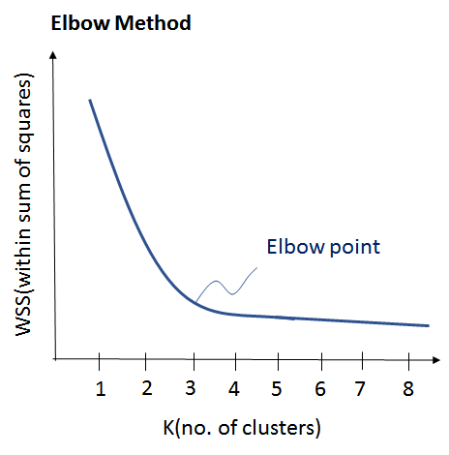

Fig. 7. Visualisation of Elbow method to select k (number of clusters).

The major objective of the k-means algorithm is to minimize the sum of quadratic errors within each cluster. A high-dimensional dataset

Xi =

is divided into ’k’ clusters with ‘m’ data points

S **=**

and k-means method is used to reduce the inter-cluster distances and increase intra-cluster cohesion. The simplest kind of k-means clustering technique that uses Euclidean distance decision-making is as follows:

Euclidian distance: (1)

**2.3** **Characterization on the basis of load flexibility.**

For instance, since HVAC systems store heat, this would be a good indication that they have load flexibility. HVAC systems’ energy consumption highly depends on temperature changes. Given the dramatic temperature differences between seasons, we can assume that variations in seasonality might be informative about the presence of HVAC systems. The following formulas from the annual load profile matrix X are used to compute the inter-season variance:

(3)

**2.4 FORMULATION OF DEMAND RESPONSE**

A carefully crafted Demand Response (DR) program has been put in place to evaluate performance levels for selected customers. This initiative’s grand focus is ensuring utility profits are maximized while taking note of every peculiar constraint unique to each customer it serves. Mathematically, this effort can be Objective: minimize

(5)

Subjected to

(6)

This is where Ui is the utility function for each consumer, Pi indicates power consumption, and are an extreme level and low level for energy consumption respectively, anddenotes a slight variation in flexibility among consumers. Furthermore, this optimization framework intricately integrates the imperative of daily energy consumption constraints, thereby orchestrating a meticulous orchestration of demand management endeavours.

The use of solar power is also incorporated in the optimization problem by subtracting the stored energy from the solar in daylight to use it in during peak time at night. This can be achieved by dividing the total stored solar energy into number of peak interval and then subtracting the obtained value from the of that particular interval.

While using the stored solar in the optimization the total energy consumption will also be reduced by the same amount as the solar energy is used.

**2.4.1 The Particle Swarm Optimization (PSO)**

The Particle Swarm Optimization (PSO) algorithm is a computational method for optimization, which takes inspiration from how birds flock or fish school in their social behaviour. In Particle Swarm Optimization (PSO), a group of potential solutions, referred to as particles, navigate across the search area with the aim of discovering the best possible solution. Every individual particle changes its position by learning from its own experiences as well as the experiences of the particles around it.  
Begin: the process by randomly setting the position and velocity of particles within the designated search area.  
Assessment: Assess the suitability of every particle according to a predetermined objective function.  
Update the speed and location of each particle by considering its individual optimal position as well as the optimal position in its neighbourhood.  
Optimization: involves repeatedly performing the update process until a certain condition is satisfied, such as reaching the maximum number of iterations or achieving convergence.  
Termination: Cease the algorithm when the termination condition is met, and provide the optimal solution discovered.  
PSO is known for its simplicity, effectiveness, and capacity to manage search spaces with numerous dimensions. It can be used for optimization problems that involve both continuous and discrete variables without needing gradient information. However, PSO could face difficulties with finding the best solution within a specific area and its performance may be influenced by the values of its parameters.

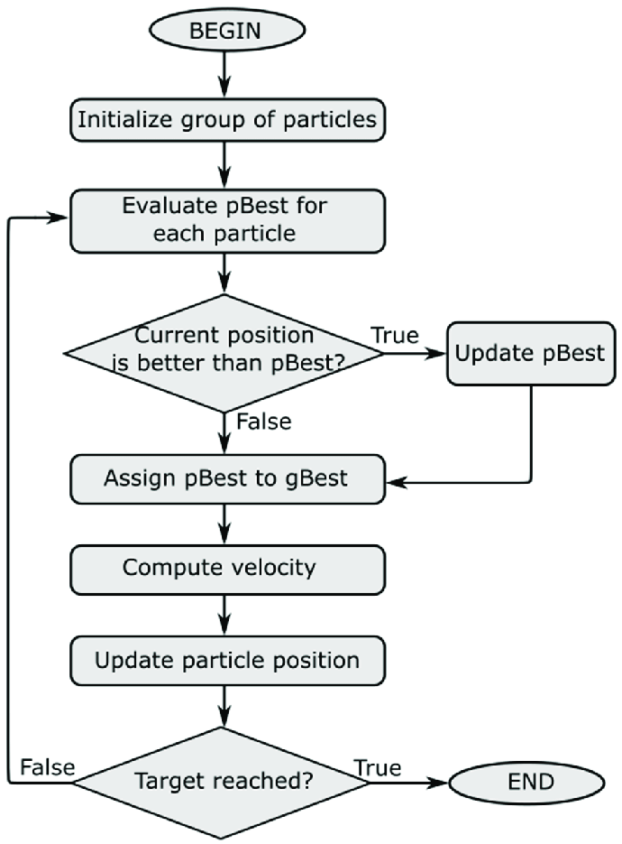

Fig. 8. PSO (Particle swarm optimization algorithm) flow chart.

**CHAPTER 3**

**RESULTS AND DISCUSSION**

During the investigation, 300 Household customers were analysed with data available at 30-minute intervals over a one-year duration. Three key technical parameters were considered to identify target customers: Fig 9 shows a probability density map illustrating the average daily consumption by consumers. That has an average of 15.27 kWh and a standard deviation of 6.43 kWh.

**3.1 Quantum of load:**

A probability density map is fitted to show the normal distribution pattern of load across the area. Remarkably, according to the analysis conducted, the minimum daily average consumption amounting to 4.50 kWh between selected residential clients. After which these customers are categorized into three distinctive load groups that include (4.50-8.84 kWh), (8.84-21.7 kWh), and in excess of 21.7 kWh which represent low, medium, and high loads respectively correspondingly. The variation in energy density within each load group shows that it is greatest for high-load.

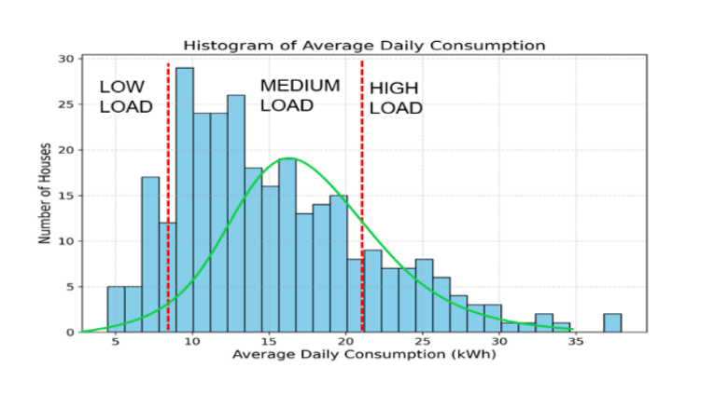

Fig. 9. Customers Segmentation according to load quantity.

**3.1.1 PV production yearly**

The mean of yearly PV generation is 2182.56kWh and the median of yearly PV generation is 1815.70kWh.

The mean yearly PV production is 1297.38 kWh/kWp.

Yearly PV production = (Yearly generation of the customer kWh)

(Generation capacity kWp)

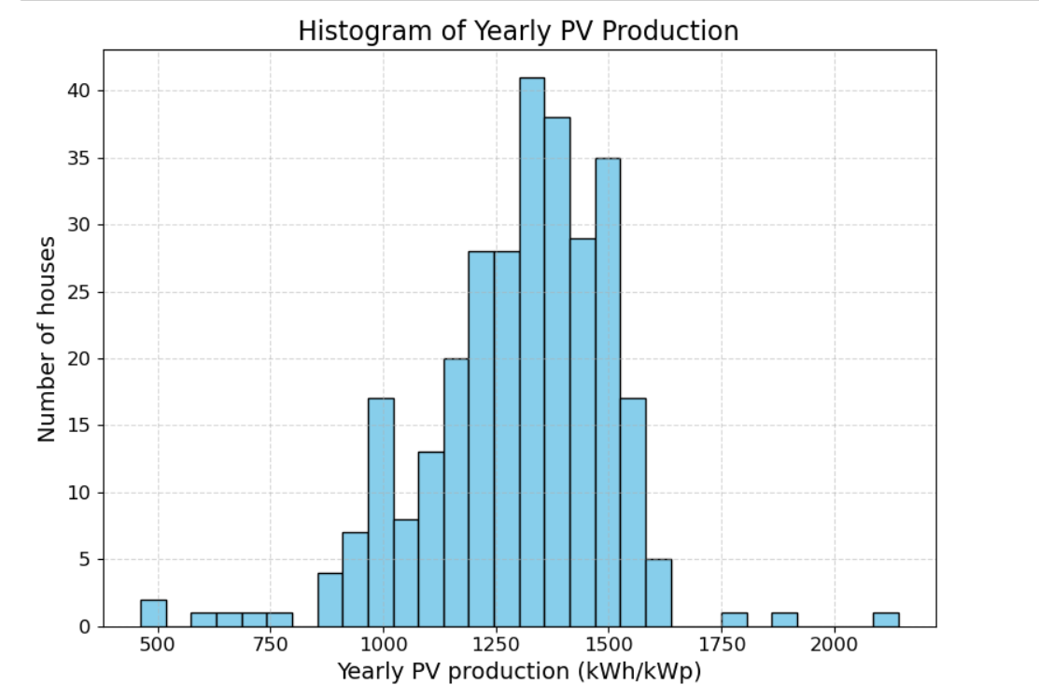

Fig. 10. Histogram of Yearly PV Production.

**PV installations with bad performance:**

|  |  |
| --- | --- |
| Customer | Yearly PV generation (kWh) |
| 6 | 579 |
| 92 | 462 |
| 116 | 476 |
| 226 | 670 |

Observation: bad performance relates to periods of blank production (less than 700kWh).

Table. 1 Bad performance of PV generation.

**3.2 Timing of peak:**

Time of peak analysis: This plot shows the cluster centroids produced by the K-mean algorithm that uses the Euclidean distance formula which results in five distinct clusters. The time of peak demand for each segment is: 8 am and 9 pm; 7 am,12 noon, and 6:20 pm; 8:20 am and 6:30 pm; 12:30 am and 6 pm;11:40 am and 8:50 pm.

**Elbow method:** Obtained the number of clusters as 5.

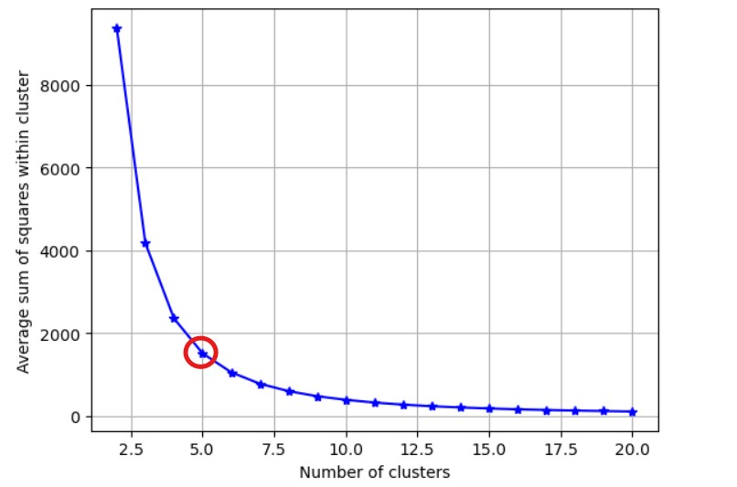

Fig. 11. k-means cluster obtained.

**k-means clusters:**

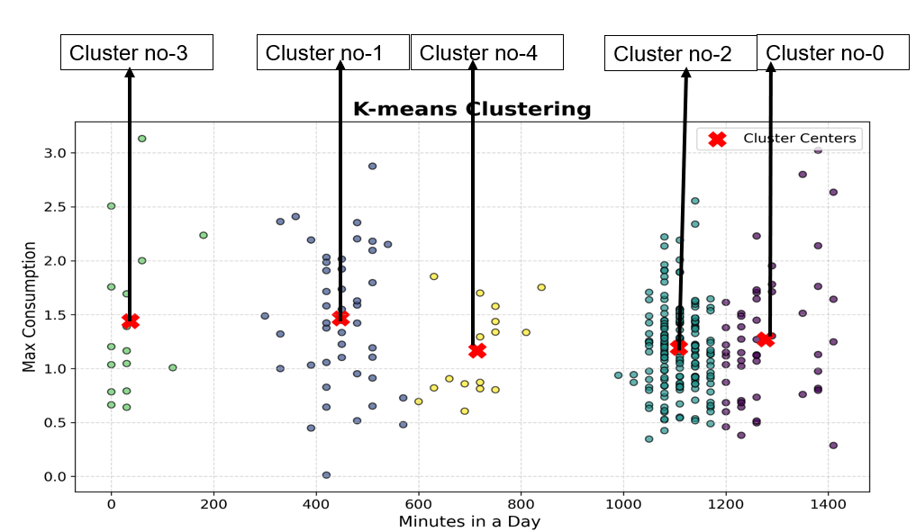

Fig. 12. k-means cluster obtained.

|  |  |
| --- | --- |
| **Clusters** | **Number of consumers** |
| Cluster no-0 | 51 |
| Cluster no-1 | 45 |
| Cluster no-2 | 172 |
| Cluster no-3 | 16 |
| Cluster no-4 | 16 |

Table. 2 Number of customers with respective cluster.

**Obtained cluster load curves:**

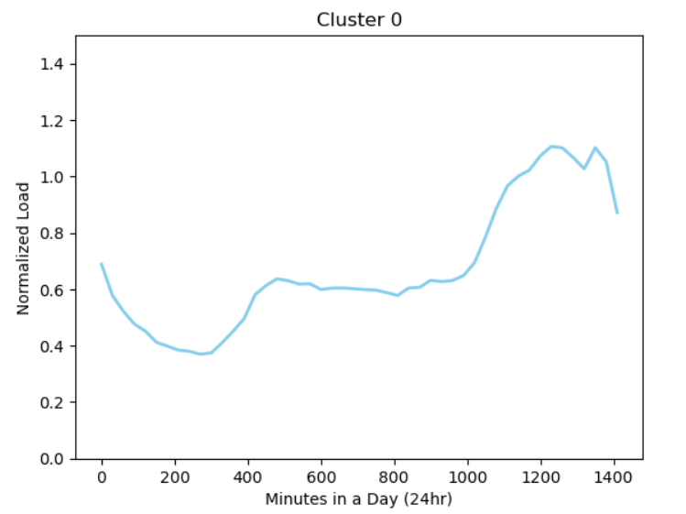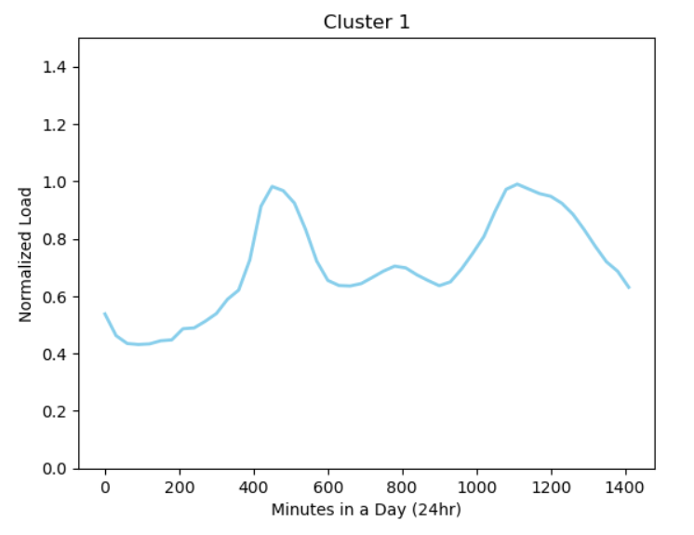 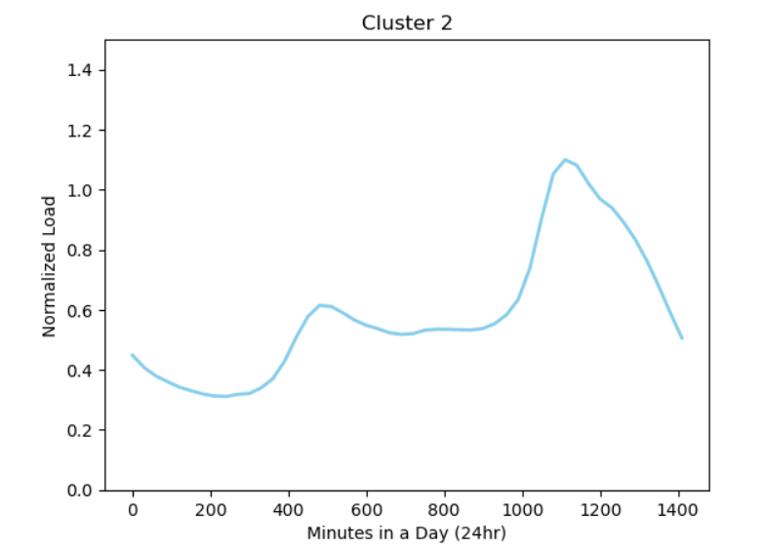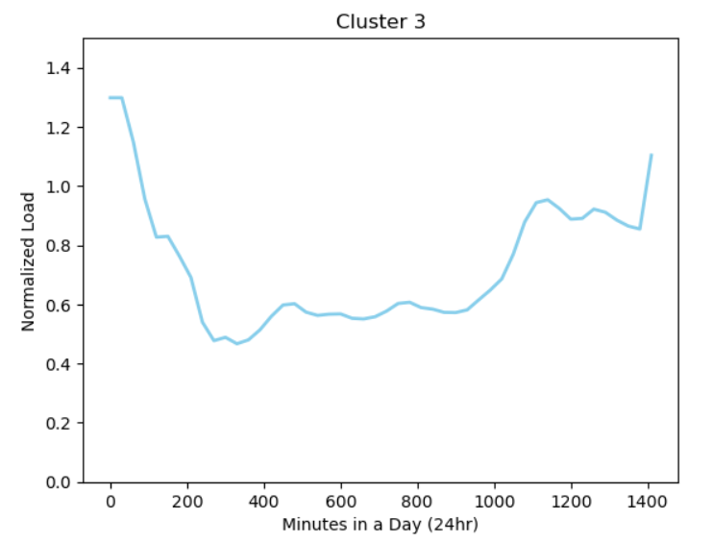

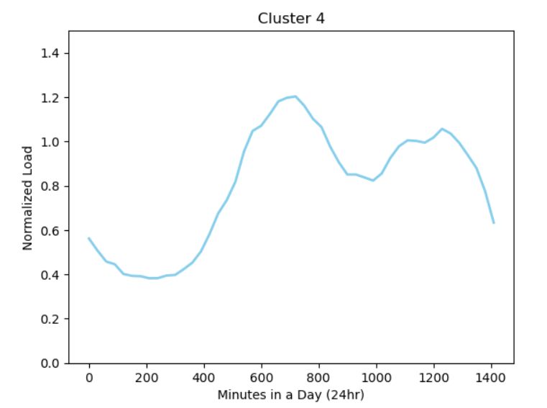

Fig. 13. Centroids of clusters (Euclidian distance utilizing K-means).

**3.3** **Flexibility in loading:**

We stated in Section 2 that temperature fluctuations have a strong correlation with the energy used by heat pump air conditioners (HVAC as discussed in Section (two), which could be regarded as an indicator of load flexibility. Fig 14 shows the typical seasonal consumption pattern for an average customer over several seasons. It is interesting to note that during summer, electricity uses peaks, while during winter it hits the bottom. Furthermore, Fig 15 illustrates a histogram plot of seasonal variation. The houses to the right of the red dashed line might contain air conditioning units and thus can represent changes in energy supply throughout the year.

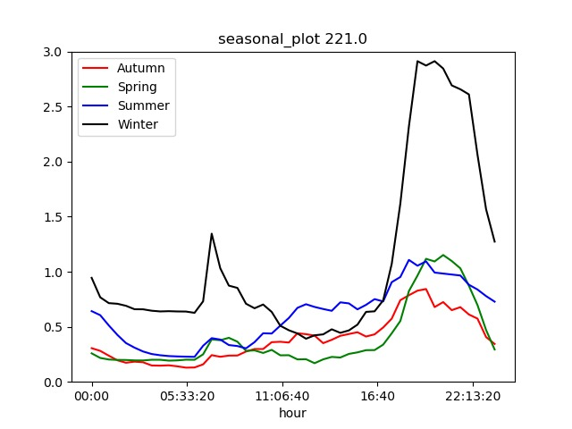

Fig. 14. (a) A Customer with high value of Variance.

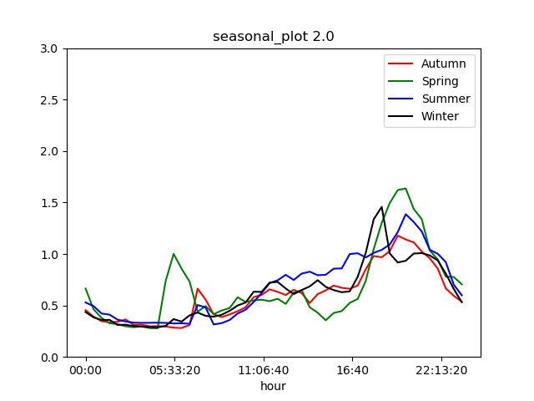

Fig. 14. (b) A Customer with low value of Variance.

Fig. 14. Seasonal average consumption of a typical customer a and b.

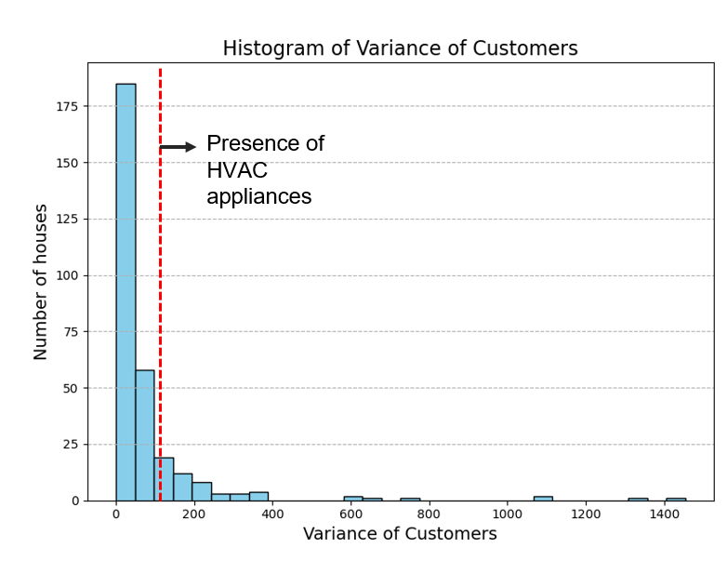

Fig. 15. Plotting of the seasonal variance histogram.

**3.4 Demand Response Formulation**

Creating Demand Response (DR) Strategies: Utilities strategically implement DR programs in their operational profiles while upholding consumer convenience and ensuring grid reliability. To achieve this, the objective of equation 5 is used as a guideline in solving an optimization problem using linear programming techniques. In Figure 16 we illustrate the complexities of electricity market dynamics and structured pricing framework for time-of-use (TOU) tariffs respectively. Utilities buy electricity in 15-minute intervals from the spot market, with the TOU pricing structure remaining the same during particular seasons to ensure consistency and predictability.

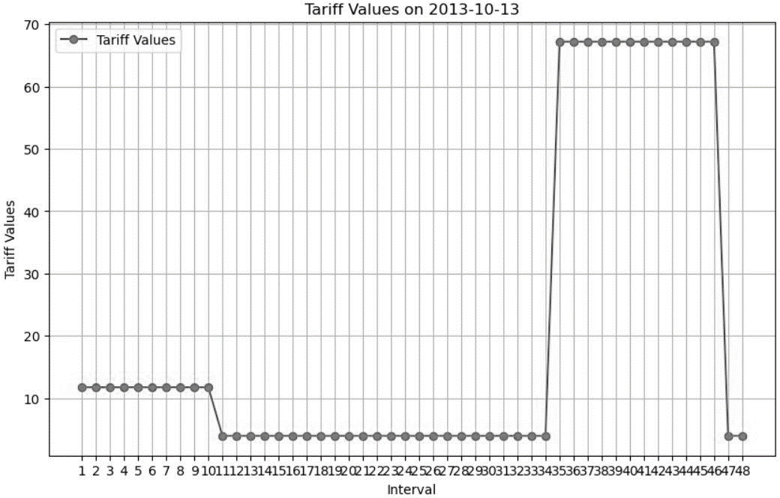

Fig. 16. TOU price structure.

Also, Fig 17 demonstrates through visual representation, the pre- and post-DR load profiles of a typical residential consumer demonstrating the great impact of load dynamics. Importantly, clear filling valleys and moving loads effects due to the TOU price structure highlight how consumers participate in system-wide peak clipping activities. Fig 18. Displays the effect of DR initiatives that shows the tangible benefits associated with involving some customers in load management interventions.

|  |  |  |
| --- | --- | --- |
| Algorithms | Percentage reduction  With PV | Remarks |
| PSO | 17.78 | The algorithm converged globally with minimum information exchange.  Load shifting technique |
| FA | 16 | More variation not suitable |
| SQP | 17.64 | More variation |
| GA | 14 | Heuristic-based load shifting technique |

Table. 3. Comparisons of various algorithms.

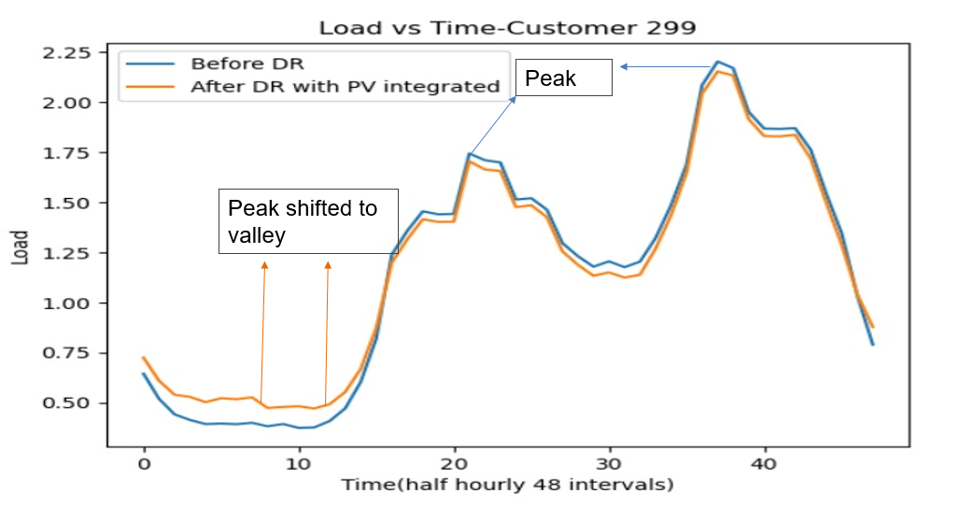

Fig. 17. Impact of DR on a particular residential customer (299).

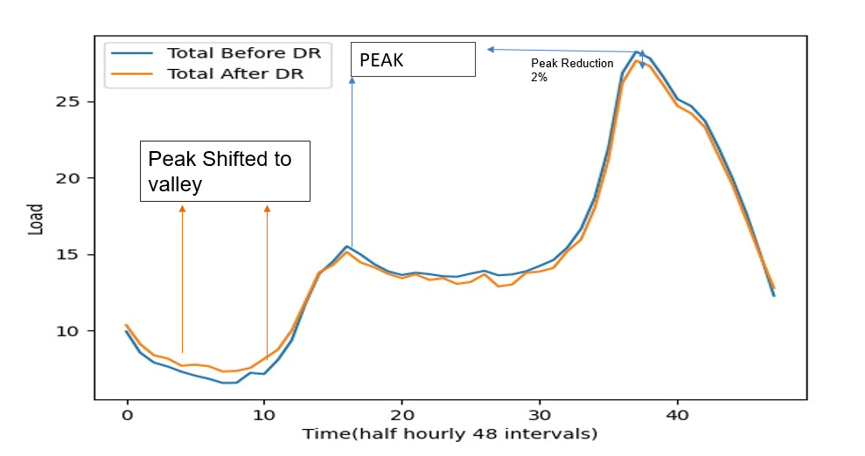

Fig. 18. DR’s impact on the profile of system load.

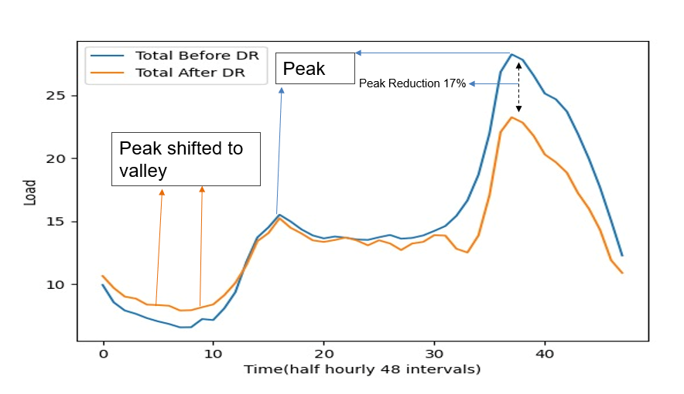

Fig. 19. Impact of DR on the PV system load profile.

**CHAPTER 4**

**CONCLUSIONS AND SCOPE FOR FUTURE WORK:**

It is a great opportunity for utility firms to use the load profiling data for designing Demand Response strategies, which enable bespoke DR interventions targeting certain consumer groups with specific behavior patterns. The k-means algorithm has exposed six distinct natural clusters within the load profile dataset. Each cluster has unique characteristics that are marked by changes in the shape of profiles, hence making it possible to understand subtle differences in how people behave. Moreover, the examination enabled the graphical representation of various vital customer details such as demand fluctuation; weekday versus weekend operation; susceptibility to climatic parameters, and simultaneous peak loads. This simplifies energy consumption awareness among customers. By using this approach, 70 probable customers out of 300 have been identified for focusing on DR schemes. With their participation, these chosen clients cut down the system’s peak demand by an impressive 17% with PV use and thus revealing practical advantages associated with grid-optimized operations using evidence-based techniques resulting in better efficiency overall.

Moving forward, our plan entails further refining and enhancing our models, as well as exploring alternative techniques to enhance their performance. We aim to continually improve the accuracy and reliability of our forecasting models for time series analysis in the future.